Experiment No. 4:

Feature Encoding Techniques for Machine Learning

1. Aim
To study and understand different feature encoding techniques used in machine learning for
converting categorical data into numerical format, including Label Encoding, One-Hot Encoding, and Ordinal Encoding.

2. Objectives
• To understand the concept of categorical variables in datasets.
• To study the importance of feature encoding in machine learning models.
• To learn different encoding techniques such as Label Encoding, One-Hot Encoding, and Ordinal Encoding.
• To analyze when each encoding technique should be used.
• To prepare categorical data so that it can be used by machine learning algorithms.

3. Software Required
• Python 3.x
• Jupyter Notebook / Google Colab / Anaconda
• Pandas Library
• NumPy Library
• Scikit-learn Library

4. Introduction
In machine learning datasets, many features contain categorical values such as:
• Gender (Male / Female)
• Education Level (Graduate / Postgraduate)
• City Names
• Product Categories
Most machine learning algorithms require numerical input data and cannot process categorical
values directly.
Therefore, categorical data must be converted into numerical format before training machine
learning models. This process is called Feature Encoding.

Feature encoding ensures that:
• Data becomes machine-readable.
• Algorithms can process categorical variables efficiently.
• Model performance improves by representing categories properly.
Different encoding techniques are used depending on whether the categorical variable is nominal or ordinal.

5. Types of Categorical Variables
Categorical variables are generally divided into two types.

5.1 Nominal Variables
Nominal variables represent categories without any natural order or ranking.
Examples:
• Color (Red, Blue, Green)
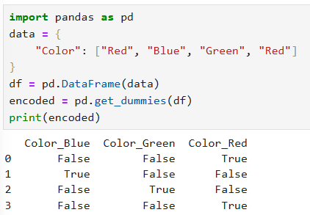
• City (Delhi, Mumbai, Pune)
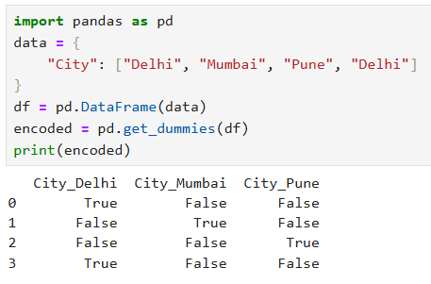
• Gender (Male, Female)
Since there is no logical order, encoding techniques such as One-Hot Encoding are commonly used.
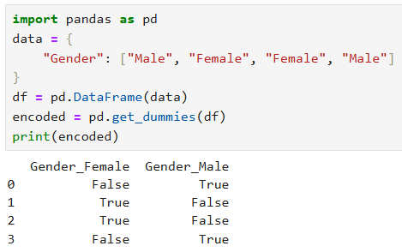

5.2 Ordinal Variables
Ordinal variables represent categories that have a natural order or ranking.
Examples:
• Education Level (High School < Graduate < Postgraduate)
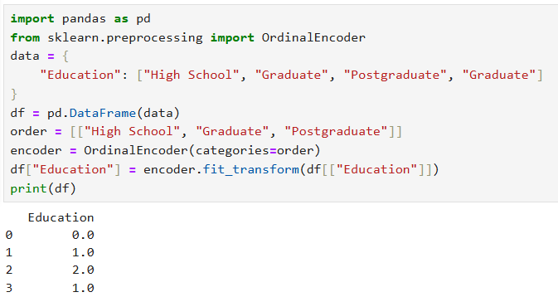
• Customer Satisfaction (Low < Medium < High)
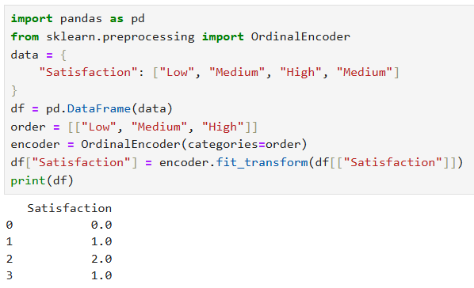

• Size (Small < Medium < Large)
In this case, encoding techniques such as Ordinal Encoding are preferred.
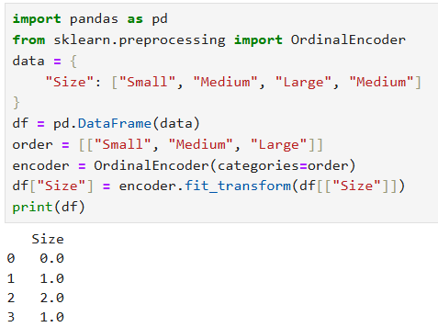
6. Label Encoding
Label Encoding is a technique used to convert categorical values into numerical labels.
In this method, each category is assigned a unique integer value.
Example:
Category | Encoded Value
Yes | 0
No | 1
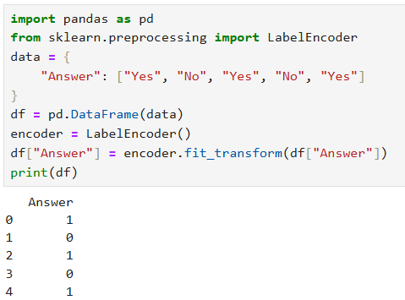

7. One-Hot Encoding
One-Hot Encoding converts each category into a separate binary column.
For each category, the value is represented as:

• 1 – if the category is present
• 0 – if the category is absent
Example:

Color | Red | Blue | Green
Red | 1 | 0 | 0
Blue | 0 | 1 | 0
Green | 0 | 0 | 1

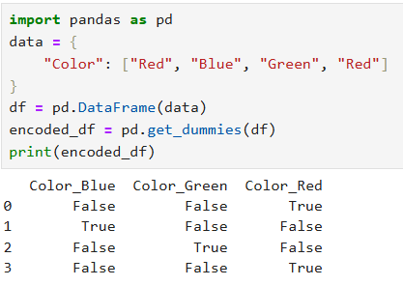
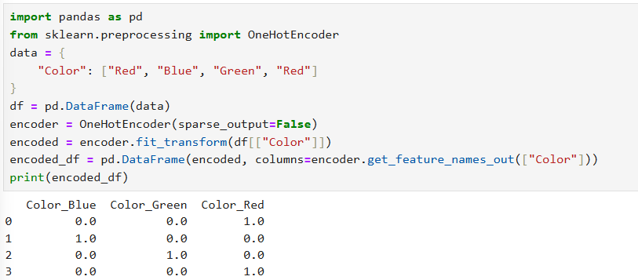

8. Ordinal Encoding
Ordinal Encoding assigns ordered numerical values to categories based on their natural ranking.
Example:

Education Level | Encoded Value
High School | 1
Graduate | 2
Postgraduate | 3

This method preserves the order relationship between categories.
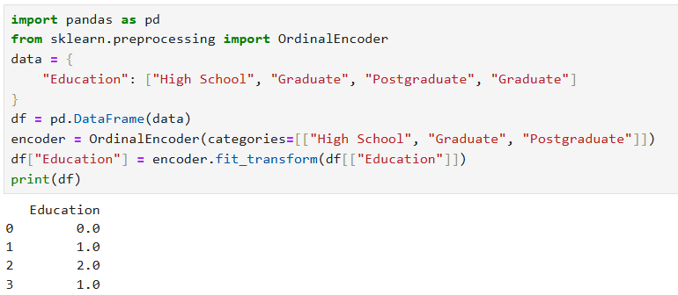

9. Result
The experiment successfully demonstrated different feature encoding techniques, including Label Encoding, One-Hot Encoding, and Ordinal Encoding, used to convert categorical variables into numerical form for machine learning models.

10. Conclusion
Feature encoding is an essential step in machine learning data preprocessing. Different encoding techniques should be selected based on the nature of categorical variables to ensure accurate model training and improved performance.

Viva Questions

1. What is feature encoding in machine learning?
Feature encoding is the process of converting categorical data into numerical form so that machine learning algorithms can process it.

2. Why is encoding necessary in machine learning?
Encoding is necessary because most machine learning algorithms work only with numerical data and cannot process text categories directly.

3. What are categorical variables?
Categorical variables are features that represent categories or groups such as gender, color, or city.

4. What is the difference between nominal and ordinal variables?
- Nominal variables → Categories with no natural order (e.g., color, city).
- Ordinal variables → Categories with natural order or ranking (e.g., education level).

5. What is Label Encoding?
Label Encoding is a method that assigns a unique integer value to each category.

6. What is One-Hot Encoding?
One-Hot Encoding converts each category into a separate binary column with values 0 or 1.

7. What is Ordinal Encoding?
Ordinal Encoding converts ordered categorical variables into numerical values based on their ranking.

8. What is the main disadvantage of Label Encoding?
Label Encoding may introduce a false order relationship between categories that do not actually have ranking.

9. Why is One-Hot Encoding preferred for nominal data?
Because nominal data has no natural order, and One-Hot Encoding avoids creating false relationships between categories.

10. What problem can occur due to One-Hot Encoding in large datasets?
It can create many additional columns, increasing the dimensionality and memory usage.

11. When should Ordinal Encoding be used?
Ordinal Encoding should be used when categorical data has a natural order or ranking.

12. What is dimensionality in One-Hot Encoding?
Dimensionality refers to the number of features (columns) created after encoding, which increases when many categories are present.

